**LAB # 02**

**COMPUTER FOUNDAMENTAL LAB**

Window 10 Installation



**Batch # 23**

**CSE102L Computer fundamental Lab**

Submitted by: **AWAIS SADDIQUI**

Registration No. : **50620**

Class Section: **A**

“On my honor, as student of University of Engineering and Technology, I have neither given nor received unauthorized assistance on this academic work.”

Submitted to:

**Engr. Abdullah Hamid**

(November 29, 2021)

Department of Computer Systems Engineering

University of Engineering and Technology, Peshawar

**Installation Of Window 10:**

Window 10 can be install by the following steps

**STEP # 01:**

First of all we download window 10 from *https://www.google.com/*

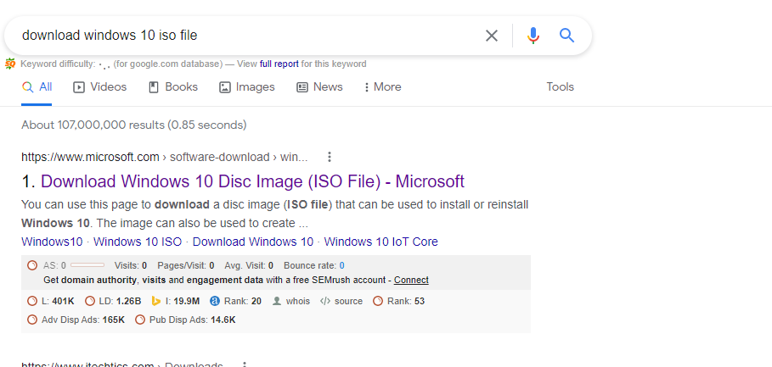

And then download the window 10

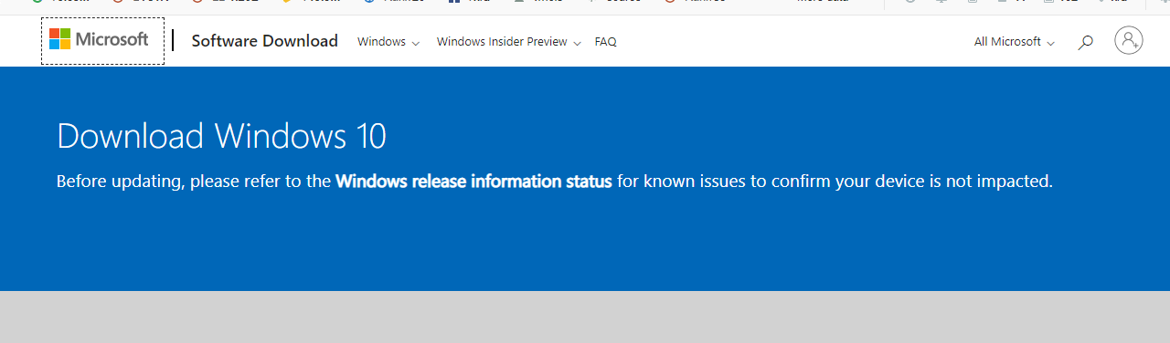

**Step # 02 :**

Install the downloaded setup of window 10 to your computer.

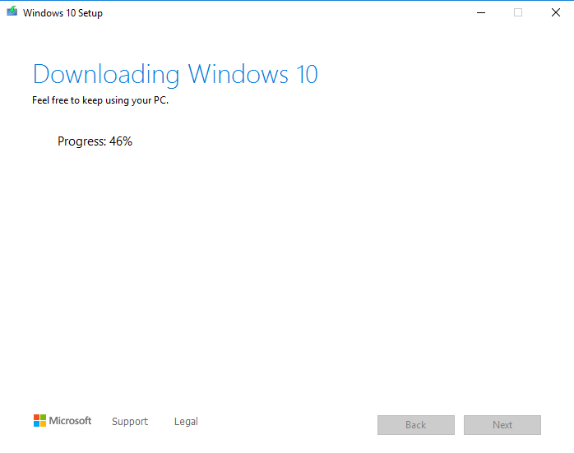

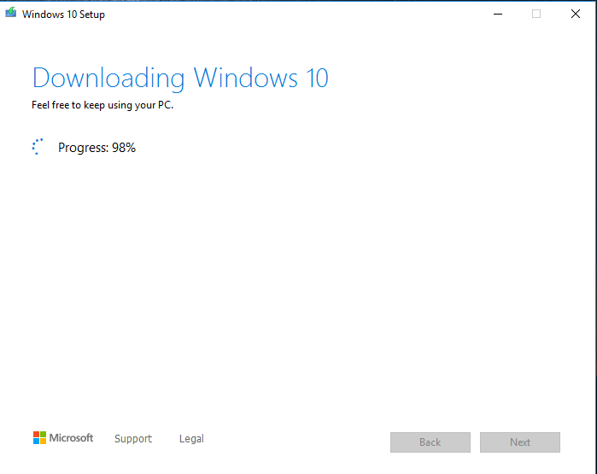

**Step # 03:**

Now make a USB bootable for window Installation.

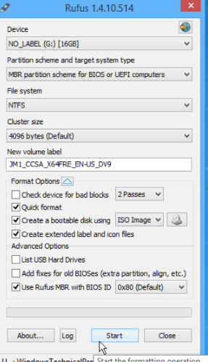

Chose the browse place to save the setup.

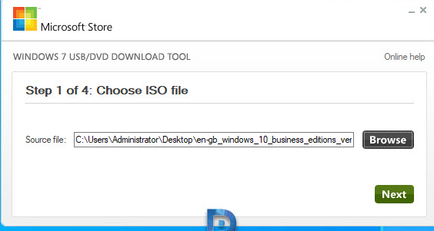

Select the USB device option.

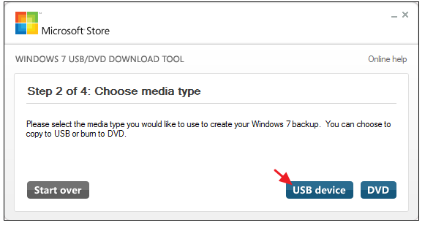

Click on the (start over)

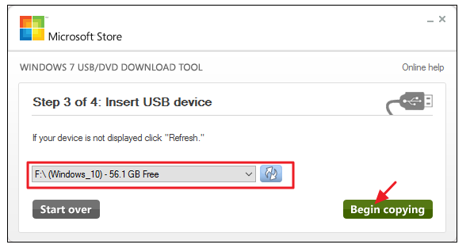

Creating bootable USB device.

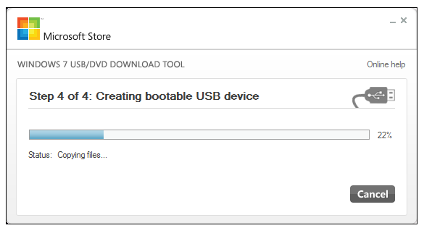

Bootable USB is created successfully.

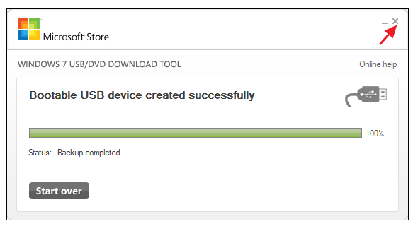

The USB is now booted successfully.

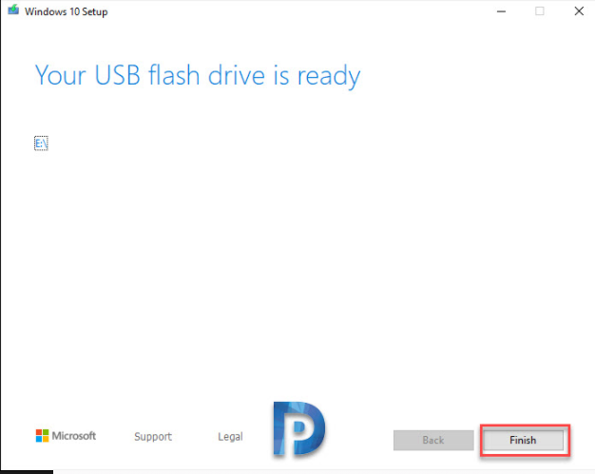

**Step# 04:**

Now install the window from bootable USB.

Select **USB flash drive**, and then click **Next**.

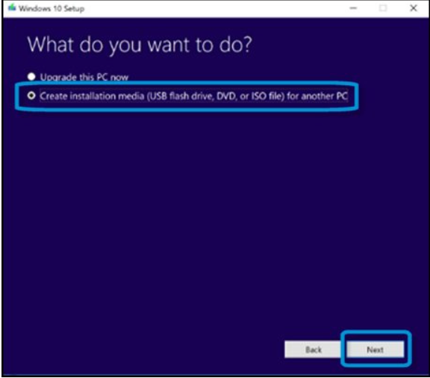

Click on Install now.

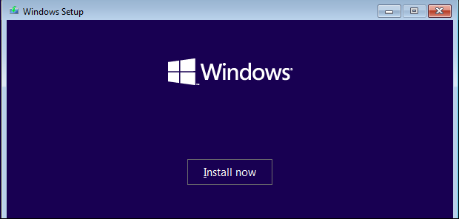

Select the language and keyboard layout, and then click **Next**.

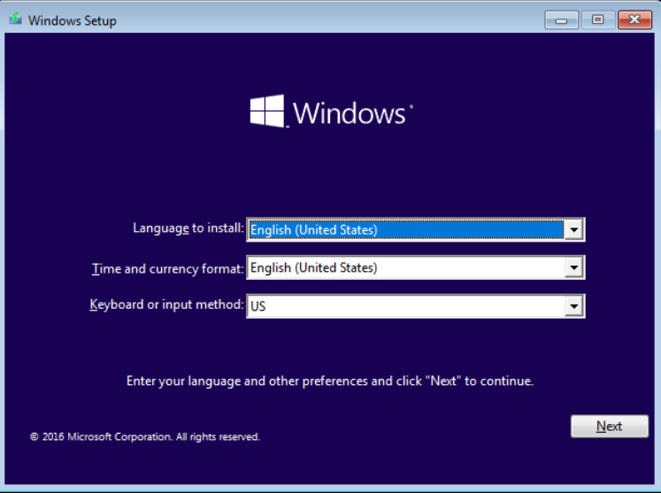

Select the edition of the operating system to install, and then click **Next**.

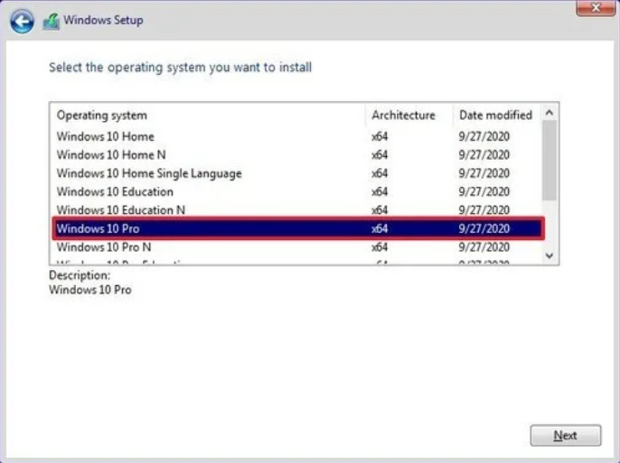

Click **Format** to format the drive, and then click **Next** to start the Windows installation.

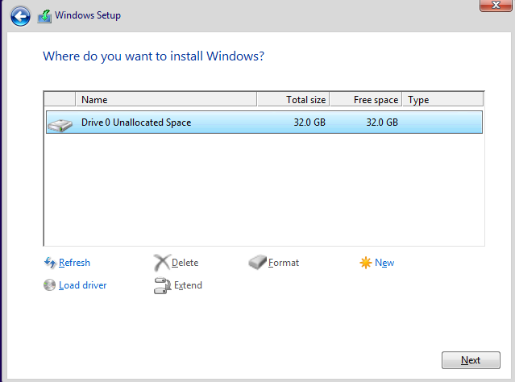

Windows 10 will install itself, and may restart a few times during this process.

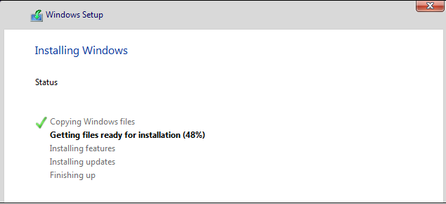

Finally Windows 10 is completed from USB.

